**Mandatory hands-on**

**Exercise 1: Configuring a Basic Spring Application**

**Pom.xml**

<?xml version="1.0" encoding="UTF-8"?>  
<project xmlns="http://maven.apache.org/POM/4.0.0"  
 xmlns:xsi="http://www.w3.org/2001/XMLSchema-instance"  
 xsi:schemaLocation="http://maven.apache.org/POM/4.0.0  
 https://maven.apache.org/xsd/maven-4.0.0.xsd">  
 <modelVersion>4.0.0</modelVersion>  
 <groupId>com.example</groupId>  
 <artifactId>LibraryManagement</artifactId>  
 <version>1.0-SNAPSHOT</version>  
 <properties>  
 <java.version>17</java.version>  
 <maven.compiler.source>${java.version}</maven.compiler.source>  
 <maven.compiler.target>${java.version}</maven.compiler.target>  
 <project.build.sourceEncoding>UTF-8</project.build.sourceEncoding>  
 </properties>  
  
 <dependencies>  
 <!-- Spring Core + Beans + Context come transitively with this single artifact -->  
 <dependency>  
 <groupId>org.springframework</groupId>  
 <artifactId>spring-context</artifactId>  
 <!-- Latest stable GA as of July 2025 -->  
 <version>6.2.7</version> <!-- requires Java 17+ -->  
 </dependency>  
 </dependencies>  
  
 <!-- Explicit compiler plugin so IntelliJ & command‑line builds stay in sync -->  
 <build>  
 <pluginManagement>  
 <plugins>  
 <plugin>  
 <groupId>org.apache.maven.plugins</groupId>  
 <artifactId>maven-compiler-plugin</artifactId>  
 <version>3.11.0</version>  
 <configuration>  
 <!-- release flag avoids “invalid target release” errors -->  
 <release>${java.version}</release>  
 </configuration>  
 </plugin>  
 </plugins>  
 </pluginManagement>  
 </build>  
</project>

**BookRepository.java**

package com.library.repository;  
  
public class BookRepository {  
 public void saveBook(String title) {  
 System.*out*.println("Saving book: " + title);  
 }  
}

**BookService.java**

package com.library.service;  
  
import com.library.repository.BookRepository;  
  
public class BookService {  
  
 private BookRepository bookRepository;  
  
 public void setBookRepository(BookRepository bookRepository) {  
 this.bookRepository = bookRepository;  
 }  
  
 public void addBook(String title) {  
 System.*out*.println("Adding book: " + title);  
 bookRepository.saveBook(title);  
 }  
}

**MainApp.java**

package com.library;  
  
import com.library.service.BookService;  
import org.springframework.context.ApplicationContext;  
import org.springframework.context.support.ClassPathXmlApplicationContext;  
  
public class MainApp { // or Main if you renamed the file  
 public static void main(String[] args) {  
 ApplicationContext ctx =  
 new ClassPathXmlApplicationContext("applicationContext.xml");  
 BookService bs = ctx.getBean("bookService", BookService.class);  
 bs.addBook("Spring in Action");  
 }  
}

**OUTPUT:**

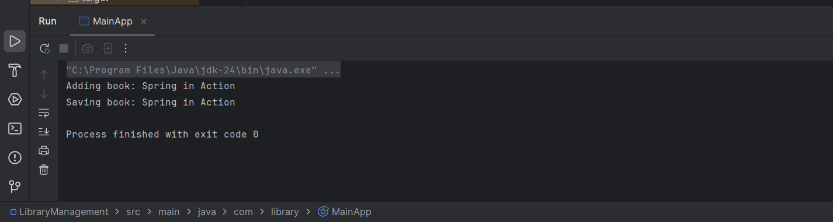

**Exercise 2: Implementing Dependency Injection**

**MainApp.java**

package com.library;  
  
import com.library.service.BookService;  
import org.springframework.context.ApplicationContext;  
import org.springframework.context.support.ClassPathXmlApplicationContext;  
  
public class MainApp {  
 public static void main(String[] args) {  
 ApplicationContext context = new ClassPathXmlApplicationContext("applicationContext.xml");  
 BookService bookService = context.getBean("bookService", BookService.class);  
  
   
 bookService.addBook("Spring in Action");  
 }  
}

**BookRepository.java**

package com.library.repository;  
  
public class BookRepository {  
 public void saveBook(String title) {  
 System.*out*.println("Saving book: " + title);  
 }  
}

**BookService.java**

package com.library.service;  
  
import com.library.repository.BookRepository;  
  
public class BookService {  
  
 private BookRepository bookRepository;  
  
  
 public void setBookRepository(BookRepository bookRepository) {  
 this.bookRepository = bookRepository;  
 }  
  
 public void addBook(String title) {  
 System.*out*.println("Adding book: " + title);  
 bookRepository.saveBook(title);  
 }  
}

**applicationContext.xml**

<?xml version="1.0" encoding="UTF-8"?>  
<beans xmlns="http://www.springframework.org/schema/beans"  
 xmlns:xsi="http://www.w3.org/2001/XMLSchema-instance"  
 xsi:schemaLocation="http://www.springframework.org/schema/beans  
 https://www.springframework.org/schema/beans/spring-beans.xsd">  
  
 <!-- Bean for BookRepository -->  
 <bean id="bookRepository" class="com.library.repository.BookRepository"/>  
  
 <!-- Bean for BookService with Dependency Injection -->  
 <bean id="bookService" class="com.library.service.BookService">  
 <property name="bookRepository" ref="bookRepository"/>  
 </bean>  
</beans>

**Output:**

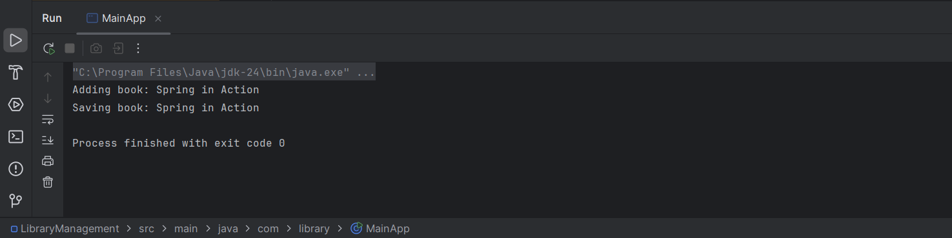

**Exercise 4: Creating and Configuring a Maven Project**

**Pom.xml**

<?xml version="1.0" encoding="UTF-8"?>  
<project xmlns="http://maven.apache.org/POM/4.0.0"  
 xmlns:xsi="http://www.w3.org/2001/XMLSchema-instance"  
 xsi:schemaLocation="http://maven.apache.org/POM/4.0.0  
 https://maven.apache.org/xsd/maven-4.0.0.xsd">  
 <modelVersion>4.0.0</modelVersion>  
  
 <!-- Update these if you prefer a different group/artifact id -->  
 <groupId>com.example</groupId>  
 <artifactId>LibraryManagement</artifactId>  
 <version>1.0-SNAPSHOT</version>  
  
 <!-- Java 1.8 as required in the exercise -->  
 <properties>  
 <maven.compiler.source>1.8</maven.compiler.source>  
 <maven.compiler.target>1.8</maven.compiler.target>  
 <project.build.sourceEncoding>UTF-8</project.build.sourceEncoding>  
 </properties>  
  
 <!-- ▸ Spring dependencies -->  
 <dependencies>  
 <!-- Spring Core / Context (brings in spring-core + spring-beans) -->  
 <dependency>  
 <groupId>org.springframework</groupId>  
 <artifactId>spring-context</artifactId>  
 <version>5.3.32</version>  
 </dependency>  
  
 <!-- Spring AOP -->  
 <dependency>  
 <groupId>org.springframework</groupId>  
 <artifactId>spring-aop</artifactId>  
 <version>5.3.32</version>  
 </dependency>  
  
 <!-- Spring Web MVC -->  
 <dependency>  
 <groupId>org.springframework</groupId>  
 <artifactId>spring-webmvc</artifactId>  
 <version>5.3.32</version>  
 </dependency>  
  
 <!-- Servlet API (provided by your servlet container / Tomcat) -->  
 <dependency>  
 <groupId>javax.servlet</groupId>  
 <artifactId>javax.servlet-api</artifactId>  
 <version>4.0.1</version>  
 <scope>provided</scope>  
 </dependency>  
 </dependencies>  
  
 <!-- ▸ Compiler plugin pinned to Java 1.8 -->  
 <build>  
 <plugins>  
 <plugin>  
 <groupId>org.apache.maven.plugins</groupId>  
 <artifactId>maven-compiler-plugin</artifactId>  
 <version>3.11.0</version>  
 <configuration>  
 <source>1.8</source>  
 <target>1.8</target>  
 </configuration>  
 </plugin>  
 </plugins>  
 </build>  
</project>

**MainApp.java**

package com.library;  
  
import com.library.service.BookService;  
import org.springframework.context.ApplicationContext;  
import org.springframework.context.support.ClassPathXmlApplicationContext;  
  
public class MainApp {  
 public static void main(String[] args) {  
 ApplicationContext context = new ClassPathXmlApplicationContext("applicationContext.xml");  
 BookService bookService = context.getBean("bookService", BookService.class);  
  
   
 bookService.addBook("Spring in Action");  
 }  
}

**BookRepository.java**

package com.library.repository;  
  
public class BookRepository {  
 public void saveBook(String title) {  
 System.*out*.println("Saving book: " + title);  
 }  
}

**BookService.java**

package com.library.service;  
  
import com.library.repository.BookRepository;  
  
public class BookService {  
  
 private BookRepository bookRepository;  
  
 public void setBookRepository(BookRepository bookRepository) {  
 this.bookRepository = bookRepository;  
 }  
  
 public void addBook(String title) {  
 System.*out*.println("Adding book: " + title);  
 bookRepository.saveBook(title);  
 }  
}

**applicationContext.xml**

<?xml version="1.0" encoding="UTF-8"?>  
<beans xmlns="http://www.springframework.org/schema/beans"  
 xmlns:xsi="http://www.w3.org/2001/XMLSchema-instance"  
 xsi:schemaLocation="http://www.springframework.org/schema/beans  
 https://www.springframework.org/schema/beans/spring-beans.xsd">  
  
 <!-- Bean for BookRepository -->  
 <bean id="bookRepository" class="com.library.repository.BookRepository"/>  
  
 <!-- Bean for BookService with Dependency Injection -->  
 <bean id="bookService" class="com.library.service.BookService">  
 <property name="bookRepository" ref="bookRepository"/>  
 </bean>  
</beans>

**OUTPUT:**



**Additonal Impotatnt HandsOn**

**Exercise 5: Configuring the Spring IoC Container**

**MainApp.Java**

package com.library;  
  
import com.library.service.BookService;  
import org.springframework.context.ApplicationContext;  
import org.springframework.context.support.ClassPathXmlApplicationContext;  
  
public class MainApp {  
 public static void main(String[] args) {  
 ApplicationContext ctx =  
 new ClassPathXmlApplicationContext("applicationContext.xml");  
 BookService bookService = ctx.getBean("bookService", BookService.class);  
 bookService.addBook("Spring in Action");  
 }  
}

**BookRepository.java**

package com.library.repository;  
  
public class BookRepository {  
 public void saveBook(String title) {  
 System.*out*.println("Saving book: " + title);  
 }  
}

**BookService.java**

package com.library.service;  
import com.library.repository.BookRepository;  
public class BookService {  
 private BookRepository bookRepository; // dependency  
 public void setBookRepository(BookRepository bookRepository) {  
 this.bookRepository = bookRepository;  
 }  
  
 public void addBook(String title) {  
 System.*out*.println("Adding book: " + title);  
 bookRepository.saveBook(title);  
 }  
}

**applicationContext.xml**

<?xml version="1.0" encoding="UTF-8"?>  
<beans xmlns="http://www.springframework.org/schema/beans"  
 xmlns:xsi="http://www.w3.org/2001/XMLSchema-instance"  
 xsi:schemaLocation="http://www.springframework.org/schema/beans  
 https://www.springframework.org/schema/beans/spring-beans.xsd">  
  
 <!-- Repository bean -->  
 <bean id="bookRepository"  
 class="com.library.repository.BookRepository"/>  
  
 <!-- Service bean with setter‑based DI -->  
 <bean id="bookService"  
 class="com.library.service.BookService">  
 <property name="bookRepository" ref="bookRepository"/>  
 </bean>  
</beans>

**OUTPUT:**



**Exercise 7: Implementing Constructor and Setter Injection**

**MainApp.java**

package com.library;  
  
import com.library.service.BookService;  
import org.springframework.context.ApplicationContext;  
import org.springframework.context.support.ClassPathXmlApplicationContext;  
  
public class MainApp {  
 public static void main(String[] args) {  
 ApplicationContext ctx =  
 new ClassPathXmlApplicationContext("applicationContext.xml");  
  
 BookService bookService =  
 ctx.getBean("bookService", BookService.class);  
  
 // Observe both constructor and setter injections at work  
 bookService.addBook("Spring in Action");  
 }  
}

**BookService.java**

package com.library.service;  
import com.library.repository.BookRepository;  
  
public class BookService {  
  
 private final String serviceName; // set via constructor  
 private BookRepository bookRepository; // set via setter  
  
 // ① Constructor for mandatory value  
 public BookService(String serviceName) {  
 this.serviceName = serviceName;  
 }  
  
 // ② Setter for optional/replaceable dependency  
 public void setBookRepository(BookRepository bookRepository) {  
 this.bookRepository = bookRepository;  
 }  
  
 public void addBook(String title) {  
 System.*out*.printf("[%s] Adding book: %s%n", serviceName, title);  
 bookRepository.saveBook(title);  
 }  
}

**BookRepository.java**

package com.library.repository;  
  
public class BookRepository {  
 public void saveBook(String title) {  
 System.*out*.println("Saving book: " + title);  
 }  
}

**applicationContext.xml**

<?xml version="1.0" encoding="UTF-8"?>  
<beans xmlns="http://www.springframework.org/schema/beans"  
 xmlns:xsi="http://www.w3.org/2001/XMLSchema-instance"  
 xsi:schemaLocation="http://www.springframework.org/schema/beans  
 https://www.springframework.org/schema/beans/spring-beans.xsd">  
  
 <!-- Repository bean -->  
 <bean id="bookRepository"  
 class="com.library.repository.BookRepository"/>  
  
 <!-- Service bean -->  
 <bean id="bookService"  
 class="com.library.service.BookService">  
 <!-- ① Constructor injection: mandatory argument -->  
 <constructor-arg value="Central Library Service"/>  
 <!-- ② Setter injection: optional dependency -->  
 <property name="bookRepository" ref="bookRepository"/>  
 </bean>  
</beans>

**OUTPUT:**

